Lab 2: Using CSS Stylesheets

If you have not used html and css before I strongly advise you to do the following walk through exercises, below. To do this you will need to download the sample code from Moodle in the folder week 2 files.
If you have experience of html and css then you can choose to go straight to the further exercises at the end of the lab worksheet.

Overview of CSS
- CSS stands for Cascading Style Sheets. CSS is a language used for describing the look and formatting of a document written in a markup language such as HTML.
- CSS was designed primarily to allow the separation of content and presentation (layout, colours, fonts, etc).
- CSS allows you to control the look of your website across multiple pages.
- CSS can also be used to control the way a web page displays depending on the viewer's device or screen size.

Using Stylesheets

Do not put formatting in HTML!!!!!

The old way of adding formatting to an HTML document was to use a formatting tag, such as font, e.g.:
<font size="7" color="red">This is large red text</font>
or to add formatting attributes to other tags, e.g.:
<p align="center">This text is centred</p>

This method is now ‘deprecated’, i.e. don’t use it. The new way is keeps all formatting information separate from the HTML by defining styles for HTML tags.

Style sheet syntax

Definitions of styles in CSS (Cascading Style Sheets) use the following syntax: -
color:red; font-size:20px;
which sets the text colour to red and the font size to 20 pixels. The syntax is as follows: -
a property, e.g. color, font-size
a colon
the value of the property, e.g. red, 20px, not in quotes
a semi-colon
followed by as many other properties and values as required.
Note:
- everything is in lower case
- some of the property names are hyphenated
- if no units are specified for numbers, they are assumed to be in pixels (px) or, for some properties, such as line-height, the number is a multiple of the normal setting. Text sizes are often given in points (pt). (1pt is roughly the same as 1px.) Some property values can be specified as percentages (e.g. width).

Where to define styles

There are 3 places in which you can define styles: -
- in-line (also called locally), i.e. in the tag they refer to, here the style applies only to the tag it is associated with on the page
- internal style sheet (also called embedded), coded at the top of the page in the head section. Here the styles apply to the entire page
- external style sheet, i.e. in a separate document with a .css extension. This allows consistent styles to be applied across multiple pages throughout a Web site.

How to code Styles
In line styles (locally) within the body
Styles can be applied directly to tags within the body of the web document like this: -
<body style= "background-color:blue; margin-left: 15%; margin-right: 15%;">}
<h1 style="font-family: Garamond, Times New Roman, serif; font-size: 200%;" >This is the page heading</h1>
<div style="background-color: rgb(204,204,255);padding: 0.5em;border: 1px solid #000000;">
<p>A div is like a paragraph but is larger and can contain many paragraphs.</p>
<p> If we style the div it will apply to all of the paragraphs and other tags contained within it
</p></div>
Internal Stylesheets in the Header
Using stylesheets in the header is applies the styles across an entire web page, but they will only apply to one document/web page.
The stylesheet below tells HTML to apply the font Arial, bold it and display in blue to all P tags in the document. If the browser cannot apply the arial font then it can use Helvetica, then Verdana and then any sans serif font. The second section starting .Style tells the stylesheet to apply similar formatting, but in green to any tag that has the class “Style1”.
To enter css in the header of a web document use the following code: -
<style type="text/css">
p {
font-family: Arial, Helvetica, Verdana, sans-serif;
font-weight: bold;
color: “blue”;
}
.Style1 {
font-family: Verdana, Arial, Helvetica, sans-serif;
font-weight: bold;
color: #FF0000;
}
.Style2 {
font-family: Arial, Helvetica, Verdana, sans-serif;
font-weight: bold;
font-size: 12pt;
color: rgb(204,204,255);
}
</style>

Note that this example uses something called .Style1. This is called a class and is a way you can make the same style apply to different tags or to enable the same tag to have different styles

Classes are applied to tag by giving then the attribute class=”classname” which in this example is class=”Style1”.

For example the tag <p class=”Style1”> will be formatted the same way as <form class=”Style1”>

But also the tag <p class=”Style1”> will be formatted differently from the tag <p class=”Style2”> which will be in a red font at 12pt size.

External Stylesheets
To include an external stylesheet in an HTML document put a reference to it in the head section of the document: -
<link rel="stylesheet" type="text/css" href="COM4006M.css" />
Then create a stylesheet file with a .css extension that looks something like this.
p {
font-family: Arial, Helvetica, Verdana, sans-serif;
font-weight: bold;
color: blue;
}
.Style1 {
font-family: Arial, Helvetica, Verdana, sans-serif;
font-weight: bold;
color: “#00FF00”;
}
.Style2 {
font-family: Arial, Helvetica, Verdana, sans-serif;
font-weight: bold;
font-size: 12pt;
color: rgb(204,204,255);
}
Using a combination of in-line, internal and external stylesheets
It is possible to use all three of the above techniques in the same document. This is where the C is CCS – Cascading comes in - what happens is that if two styles are applied to the same tag that are different – the more specific style wins i.e. p wins over Style1 or Style2 and generally in-line styles are more specific than internal or external styles.

IDs and Classes

In a style sheet, set up styles as follows:
.quotation {margin-left:10%;margin-right:10%; font-style:italic}
.warning {border:5px solid red;text-align:center}
.question {font-weight:bold;color:blue;background-color:yellow}
#first {font-color:red}
#second{font-color:blue}

This defines styles for the quotation, warning, and question classes of the p tag and for the first and second ids.
These styles would then be used in the following way:
<p id=”first”>The following quotation is from a Charles Dickens novel:</p>
<p class="quotation">I am well aware that I am the 'umblest person going. My mother
is likewise a very 'umble person. We live in an ‘umble abode.</p>
<p>Now answer the following questions:</p>
<p class="question">In which novel does this quotation appear?</p>
<p class="question">Who says it?</p>
<p class="question" id=”second”>Who do they say it to?</p>
<p>Note:</p>
<p class="warning">You only win a prize if you get all 3 questions right.</p>
Ids identify individual tags, they are unique and there can only be one id per page with the same name.
Classes can identify multiple tags, so there can be multiple tags with the same class name across the same page.

Walkthrough Exercises

The files you need for this walkthrough are on Moodle in the week2 files folder.
Do the following first before you start the exercise: -
- Create a new directory off htdocs in the Computer Science Web Server ysjcs.net. Call this directory labs
- Download the files from the folder on Moodle and rename index_4006m.html to index.html
- Copy the files to the new directory you have created on htdocs.
- Upload and overwrite as necessary when you are doing the exercises below.

- Adding CSS to your webpage

- Using the index.html file from Moodle add style.css as an external stylesheet to the webpage.
- Then add an inline style to the text of the main body, i.e. the paragraph that contains the dummy text.
Aim:
- How do I connect a CSS stylesheet to an HTML webpage?
- A separate HTML and CSS files
- The purpose of HTML vs the purpose of CSS
- Why it's good to keep content (HTML) separate from presentation (CSS)
Syntax
- The LINK tag (to connect an external CSS stylesheet to your webpage)
- The REL and TYPE attributes (to describe the CSS stylesheet)
- The HREF attribute (to specify where to find the CSS stylesheet)

- Learn CSS syntax

- Create an embedded set of styles for the page that changes the background colour of the site, the size of the H1 tag, the font colour of the dummy text.

Aim
- How (and why) CSS code looks different than HTML code (in HTML we have tags – but we have CSS has selectors). Attribute pairs have a semi-colon. Spacing in the file does not matter. Selector applies to what is in the curly bracket.
- What a "selector" does in CSS
- How to use curly brackets { } (aka opening and closing braces) in your CSS code, and what goes inside them
- How to organize your CSS code for better legibility
- How to include non-displaying comments inside your CSS stylesheet

Syntax
- The BODY selector (to control the look of the body tag in your webpage)
- The H1 selector (to control the look of H1 text)
- The P selector (to control the look of P text)
- The BACKGROUND-COLOR attribute (to change the background color)
- The COLOR attribute (to change the color)

- Changing fonts

- Update the css on the stylesheet to change the fonts and the font sizes of the dummy text.
- Specify font families so that you have fall back options for fonts

Aim
- What "web safe fonts" are and why we use these ( on user’s PCs), add in 3 - in order of preference of font
- The difference between serif and sans-serif fonts
- Why it's good to use relative (%) font sizes vs absolute (px) font sizes
Syntax:
- The FONT-FAMILY attribute (to specify the font we want)
- The FONT-SIZE attribute (to specify the size of the font)
- CSS Web Safe Fonts (including commonly used font combinations) Examples found here at: https://www.w3schools.com/cssref/css_websafe_fonts.asp

- Choosing a good colour scheme

- Alter the colour scheme in the .css file. See what happens.
Aims
- Why good colour schemes are important?
- How to create colour swatches from images
- How to identify colours by their hexadecimal values
Link to ColorExplorer: http://colorexplorer.com/ Free tool
Upload an image to this site using ‘import colors from an image’ ; let the tool present you a range of colours. Save the palette. Export the palette to a .png and .txt file.
My palette.txt has 6 hexadecimal codes. The .png has some swatch combination, and hue colours.

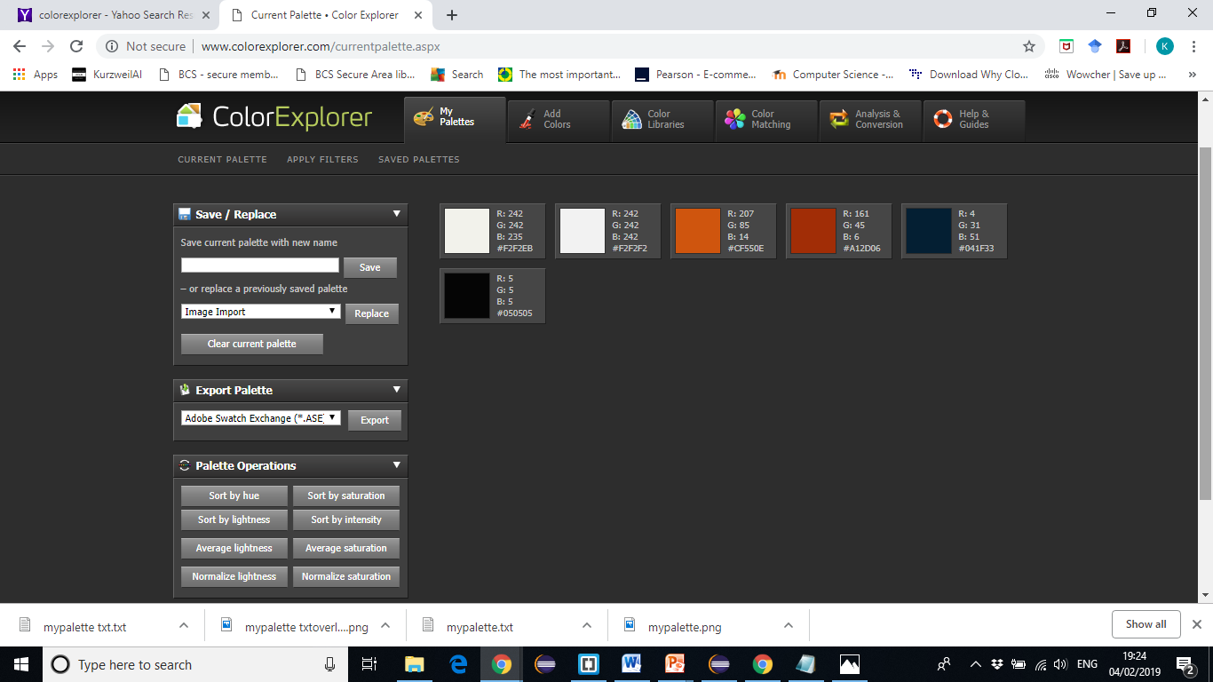
The pallet txt overlay file is a colour swatch file– shows the hexadecimal numbers and colours.
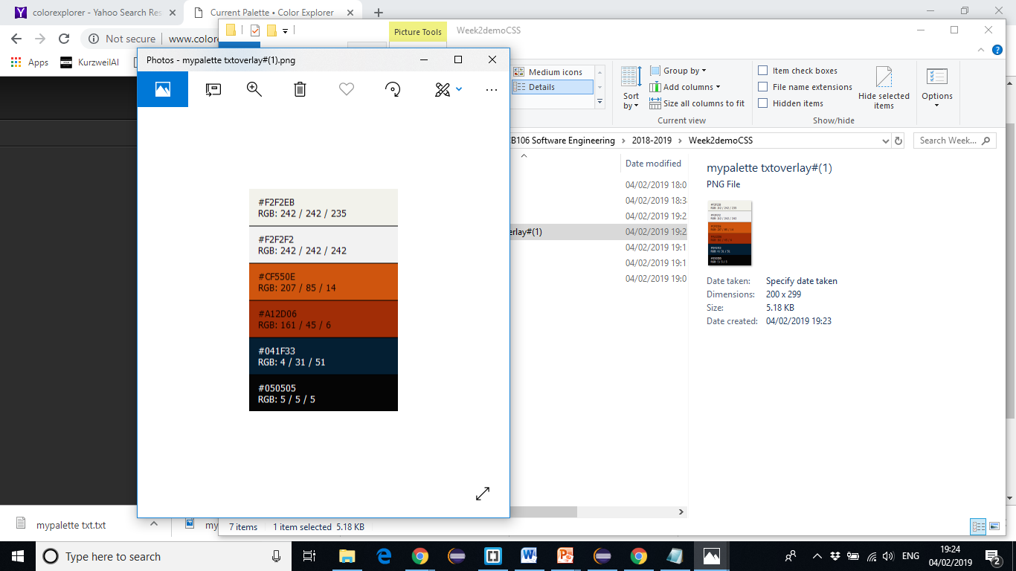
- Check CSS for mistakes
- Use the validator to check your css.
Aim
How do you make sure your CSS code doesn't have mistakes in it?
https://jigsaw.w3.org/css-validator/validator
- Why you should to check your code
- What it means to "validate" your code
- When is the right time to validate your code (early and often!)
- How to use the free W3C CSS Validation Service to troubleshoot your code
- Upload the CSS file and validate

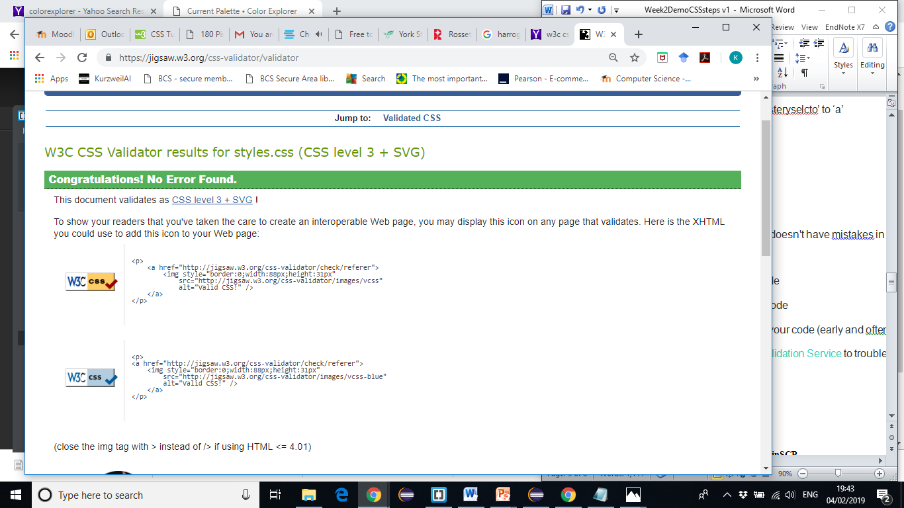

- Upload your files using SCP or WinSCP

- See last week’s instructions if you have forgotten

Use the ‘transfer your file to the computer science server’ guidelines
/* Style sheet for index.html */

body {
font-family: "Lucida Sans Unicode", "Lucida Grande", sans-serif;
background-color: #CF550E;
color: #F2F2F2;
}
h1 {background-color: #A12D06; /* turns the background of the header to red */
font-size: 300%;
}
p {
color: #F2F2F2;
font-size: 120%;
}
a {
color: #041F33;
}

- Using HTML and CSS together

- Organize the page layout into different sections
- Change the background color and size of different sections
- Center content inside sections
- Reposition sections of content
- Control the way links look on your webpage
- Change text to uppercase or lowercase
- Classify your webpage content logically
- Reposition images on your webpage
- Change the spacing around elements on your webpage

- Dividing sections of content using DIVs

- Divide your webpage layout into different "sections"
- Format your HTML code with tabs for better legibility
- Add temporary borders to DIVs to help you understand how your DIVs are positioned on your webpage
Syntax
- The DIV tag (in HTML, to identify sections of content)
- The ID attribute (in HTML, to label content on a webpage)
- The DIV selector (in CSS, to specify styles that apply to DIVs)
- The BORDER-WIDTH, BORDER-STYLE, and BORDER-COLOR attributes (in CSS, to specify how a border looks)

Things to think about:
- Work out the different sections on your page. Need to highlight the e- mail. Have a footer.
- Have a main section, priority (e-mail) and footer.
- Div id separates the different sections and links to the CSS.
- Div tag is a placeholder
- No difference on the actual published page
- Add a dashed border round each section

div {
border-width: 1px;
border-style: dashed;
border-color: white
}

- Changing the background colour of a section

- Add a div section to enclose the paragraphs containing the dummy text (if you haven’t already). Give this paragraph an id.
- Change the background colour of the div using it’s id.

Aim:
- How can you change the background color of a DIV?
- How to identify specific content in your CSS stylesheet using #ID selectors
- How to understand and predict the behavior of nested DIVs
Syntax
- #ID selectors (in CSS, to apply styles to content with a specific ID)
- The BACKGROUND-COLOR attribute (in CSS, to specify the background colour of specific content)
- The COLOR attribute (in CSS, to specify the colour of specific content)

Things to do
- Keep the footer the same as the background colour
- The priority and main div need changing background colour changes.
- Use the the div ids in the CSS file

main {
background-color: #CF550E;
}

#priority {
background-color: #041F33;
color: #050505;
}

#footer {
background-color: #CF550E;
}

- Centering content inside a section

- Change the width of the div you have just created. Use the % method to do this.
Aim
- How do you change the width of a DIV? In this lesson, you'll learn:
- How to use percentage (%) widths to create flexible, responsive webpage layouts
Syntax
- The WIDTH attribute (in CSS, to specify the width of something)

Change the priority section, - for responsive design – use:
#priority {
background-color: #041F33;
color: #050505;
width: 75%;
text-align: center;
}

#footer {
background-color: #CF550E;
text-align: center;
}

- Repositioning an entire section

- Centre the content of the div

Aim
- How do you center content inside a DIV? In this lesson, you'll learn:
- How to align text inside a DIV
- How centering content inside a DIV is different than centering the DIV itself
Syntax
- The TEXT-ALIGN attribute (in CSS, to specify how you want your text to be aligned)
- The CENTER value (in CSS, to center content)

- More on positioning

- Add a container div to the one you have been working with and change its width and alignment.
- See the affect it has on the div within it.

Aim
- How do you center an entire DIV (not just the content inside it)?
- How centering an entire DIV is different than centering the text inside a DIV
- How margins relate to a DIV's relative position on the page
- How to add a "container" DIV to contain all the DIVs on your page
- How a DIV inherits its relative width from its containing DIV(s)

Syntax
- The MARGIN attribute (in CSS, to specify the margins around something)
- The AUTO value (in CSS, to set margins "automatically" to be equal)

Things to do:
- Use margin auto to the
- Add a 4th div known as container for the general formatting in the index.html. This is added just after the <body> tag and closing </body> tag.
- Add the following container attribute before #main.

#container {
width: 80%;
margin:auto;
}

- Changing the text to uppercase or lowercase

- Change the dummy text from lower case to upper case

Aim
- How to use CSS to change text to uppercase or lowercase, rather than re-type the text
Syntax
- The TEXT-TRANSFORM attribute (in CSS, to change the case of text)
- LOWERCASE and UPPERCASE values (in CSS, to change text case to lowercase or uppercase)

Make use of the Text transform attribute – for example – all the footer is in uppercase

#footer {
background-color: #CF550E;
text-align: center;
text-transform: uppercase;
font-size: 50%
}

- Categorising your webpage content using classes

- Investigate the html code and the style.css file and identify the classes and their styles. Alter the styles of the classes and see the results

Aim:
- What "classes" are used for
- How to create classes and use these to classify content in your HTML code
- How to identify classes and apply styles to them in your CSS code

Syntax:
- The CLASS attribute (in HTML, to identify a category or "class" of content)
- The .CLASS selector (to CSS, to apply styles to specific categories or "classes" of content)

Things to do:
- Classes in CSS –may be useful for reapplying some common methods to some sections. E,g lowercase etc
- Uses .(period) create a class .lowercase that transforms the text to lowercase.
.lowercase {
text-transform: lowercase;
}

- Delete from h1 the text-transform
- Go to the index.html, and make reference to the h1 tag and include the attribute class ‘lowercase’
<h1 class='lowercase'> Coming Soon - Conversational Agents</h1>

- Changing the space around sections of content

- Add a border, margin and padding around the main and footer divs. See what effect this has. Change them.

Aim
How can you add more space inside and around DIVs on your webpage?
- What the "box model" is in CSS
- How to control the margins around something
- How to control the padding inside a DIV
- How to apply styles to specific images using #ID selectors in CSS
- Some useful shortcuts when specifying margins and padding in CSS
Syntax
- The MARGIN attribute (in CSS, to specify the space surrounding something)
- The PADDING attribute (in CSS, to specify the space between the border of a DIV and the elements inside)
- The IMG selector (in CSS, to apply styles to images)

The diagram below I think gives an instant visual understanding of the difference.
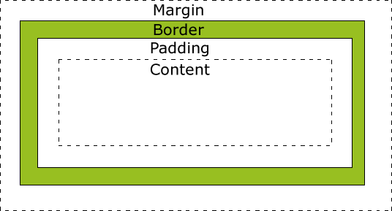
Things to follow
- Div are boxes.
- Dashed lines – is the border
- Margin –distance between text and border
- Padding is the space on the inside in the div – working in pixel.
- Add padding to the main and footer: 34px and 15px respectively
#main {
background-color: #CF550E;
padding: 30px;
}

Spacing between the images on the footer
#footer img {
margin: 5px;
}

Further Practical Exercises
- In the main page that you created last week, incorporate an Inline style sheet. Set a font, a background colour and a text colour for the first <div> tag.
- Now implement the presentation of entire the first page of the website, so that it is handled by an internal stylesheet, i.e. the stylesheet is contained within the head section of the page. At a minimum change the font, specify an alternative font, use different font colours, use different background colours, set different text alignments and use borders and margins.
- Use a class to enable the same style to be applied across a number of different tabs and ids to individually identify tags. I suggest that each div or equivalent has an id.
- Update the other pages of the website so the formatting is handled by an external stylesheet, i.e. a .css file. Use the same external stylesheet across a number of your other pages.
- Cascade a style on at least one tag, i.e. apply an internal or inline style as well as a style from an external style sheet, so that both sets of styles apply.

